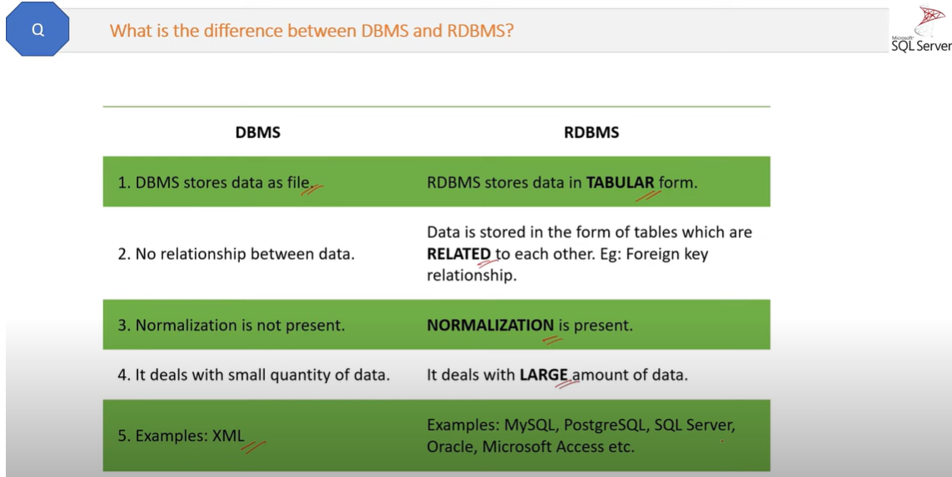

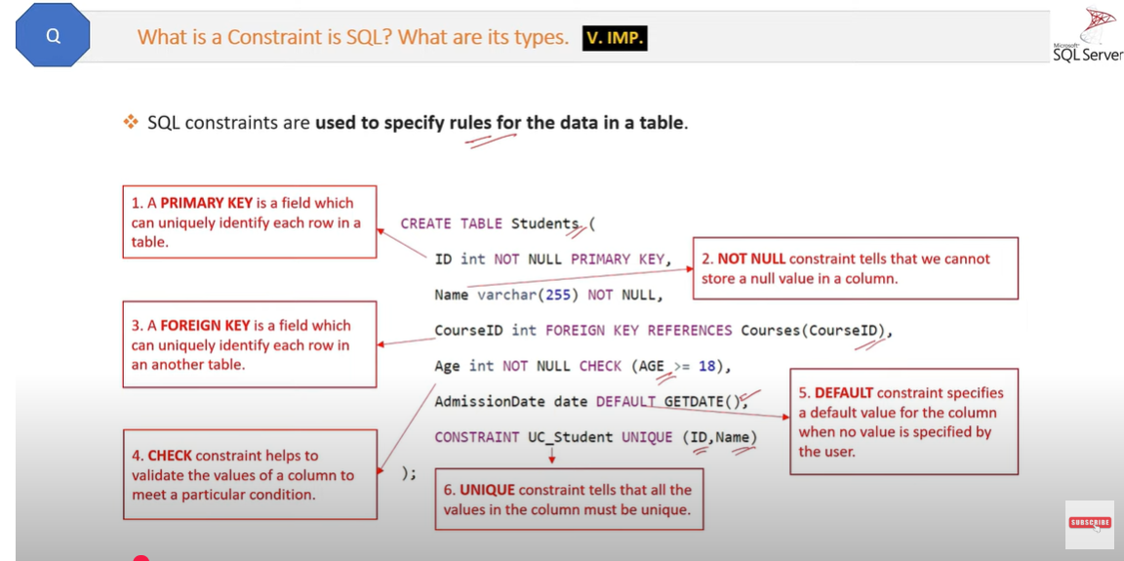

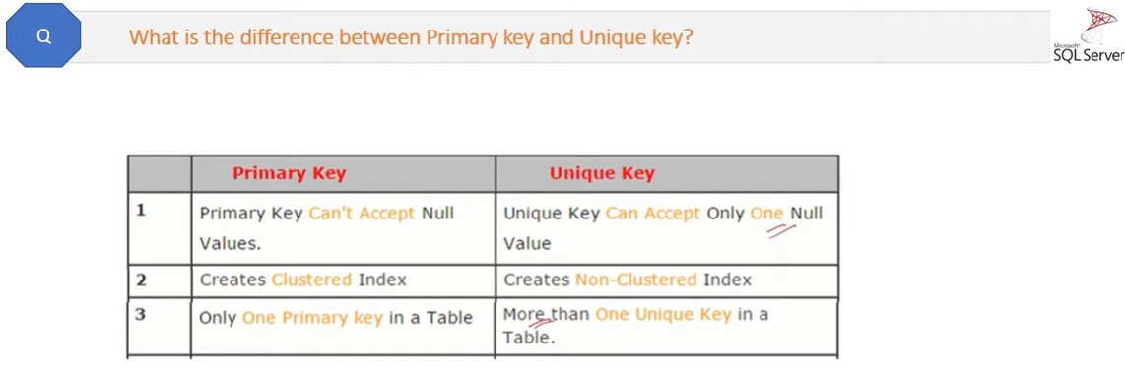

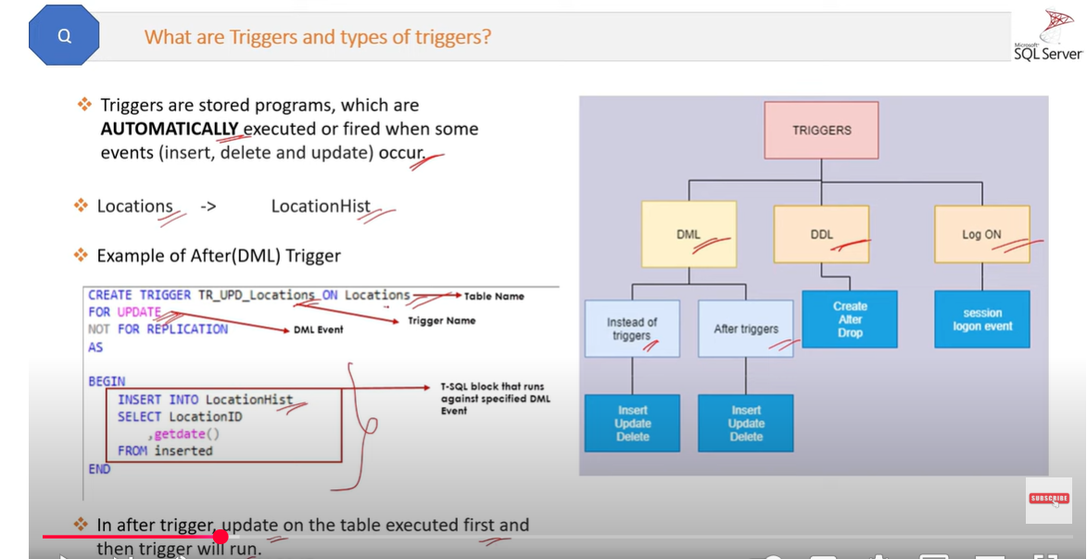

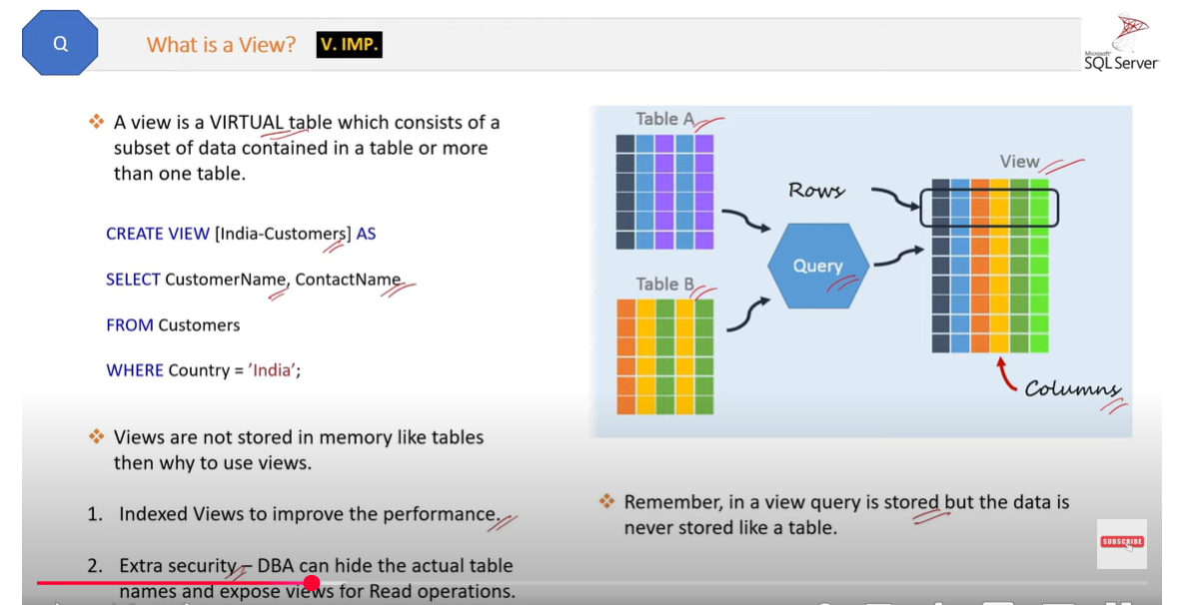

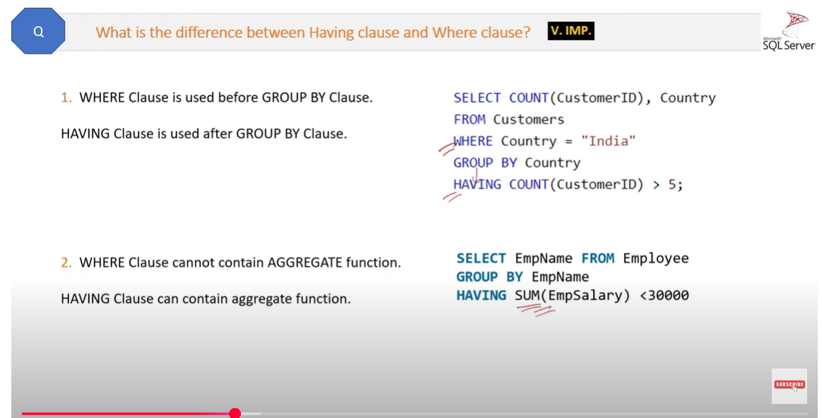

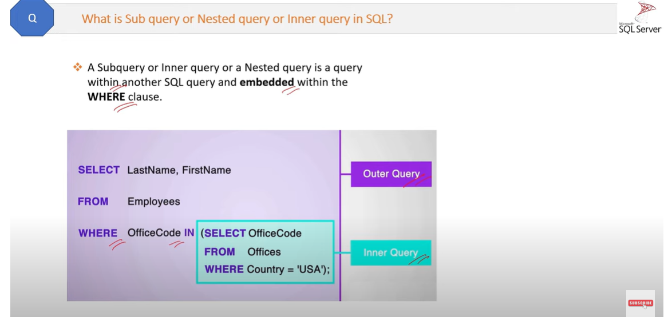

Having clause can be used without where clause.

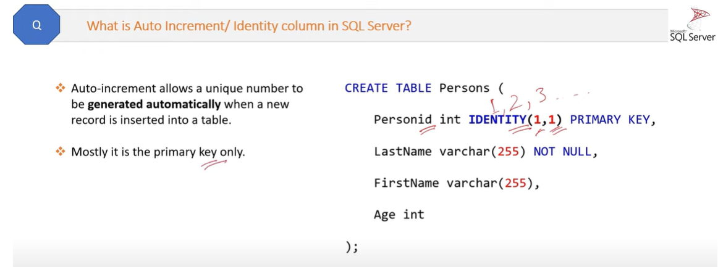

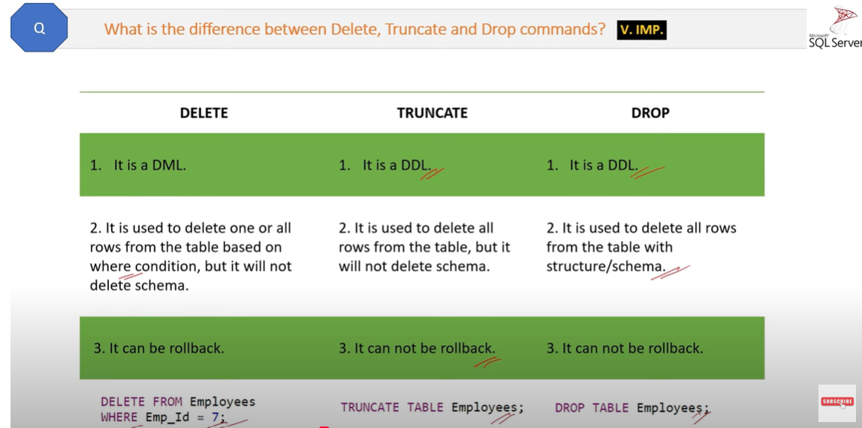

Delete will not reset the identity, but Truncate will reset the identity.

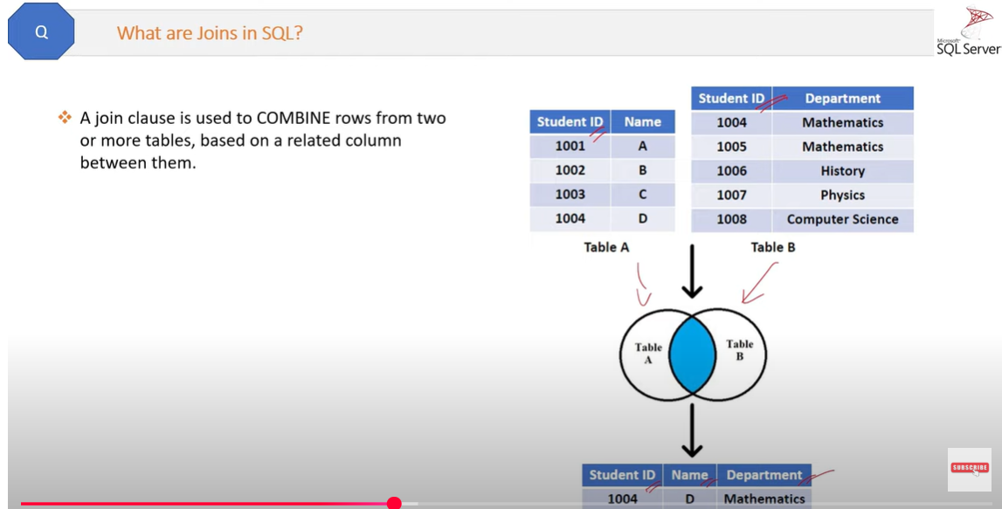

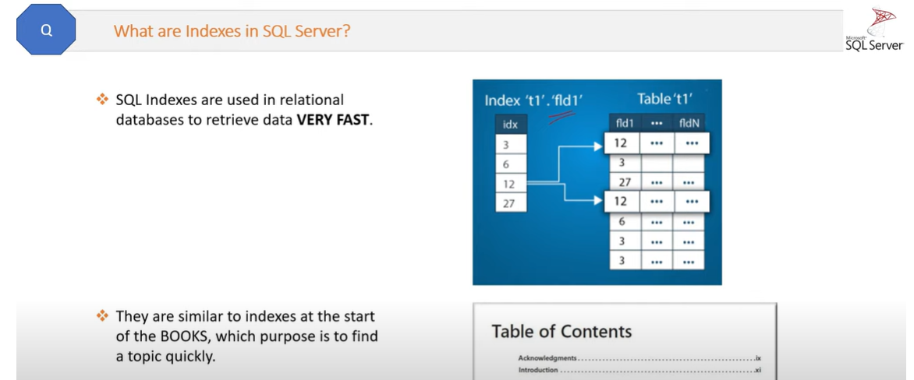

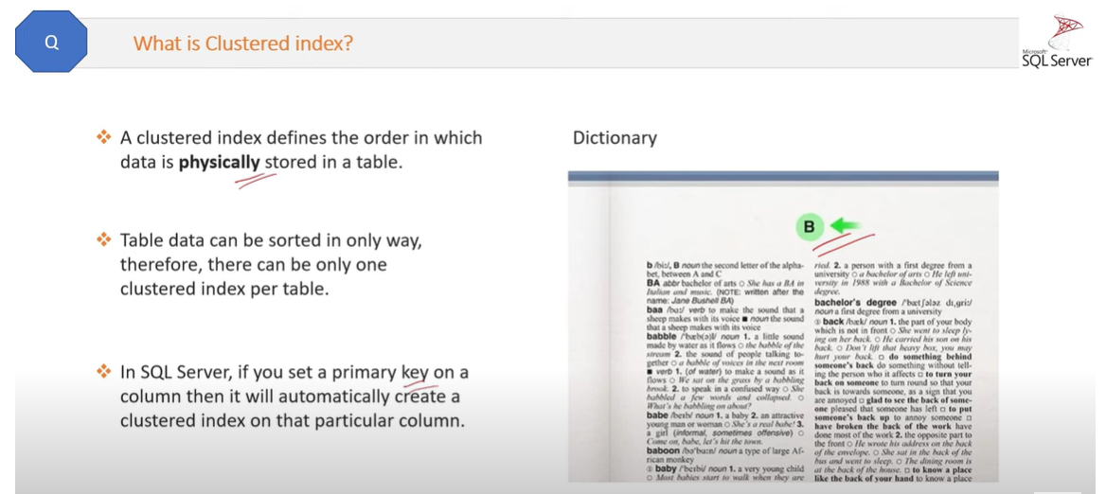

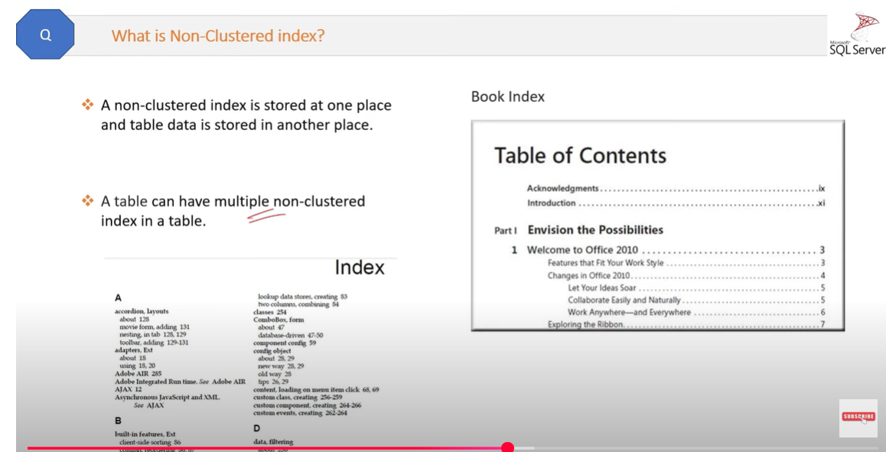

Clustered index Id is 0, whereas Non-clustered index Id >0

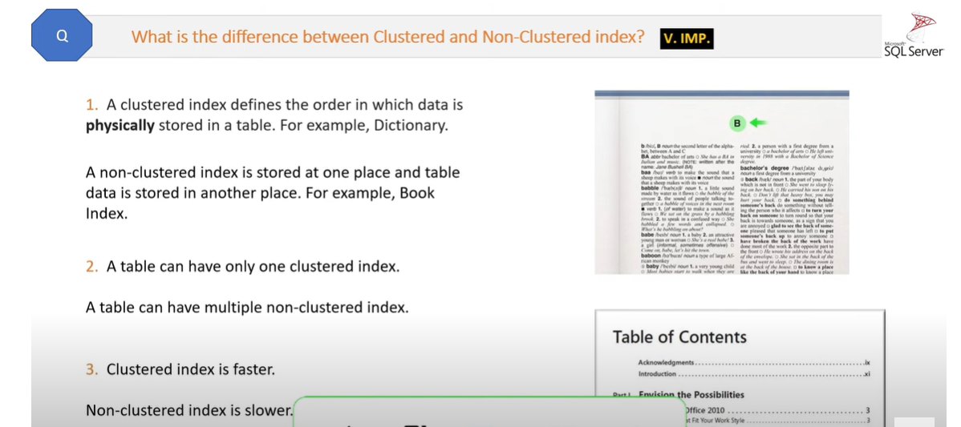

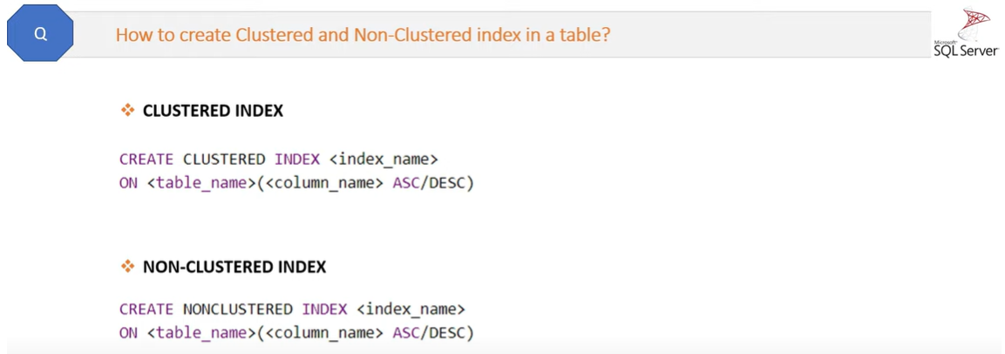

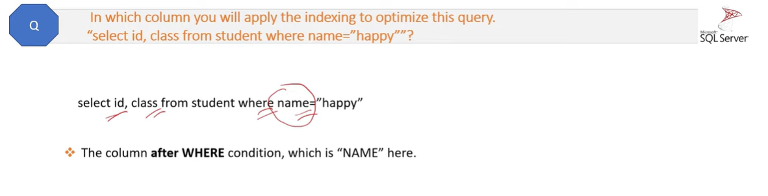

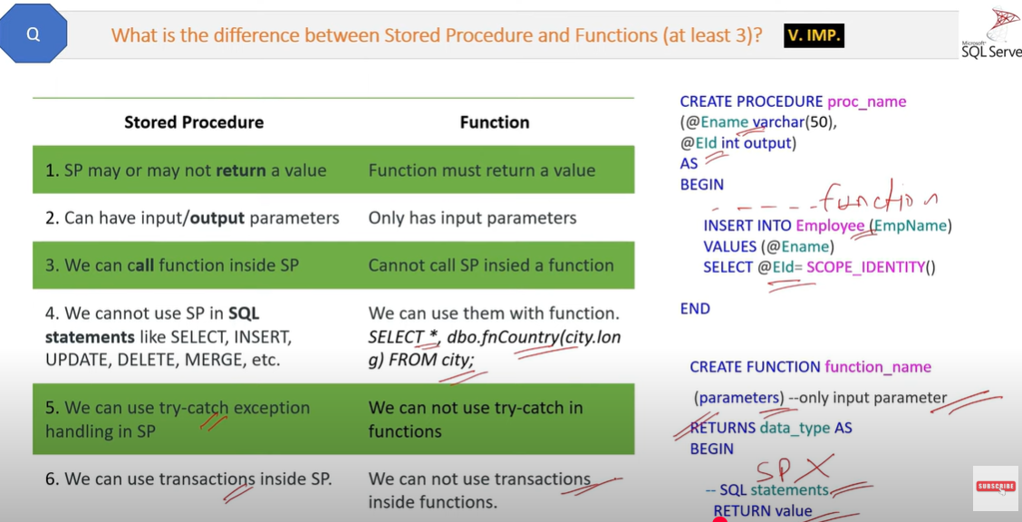

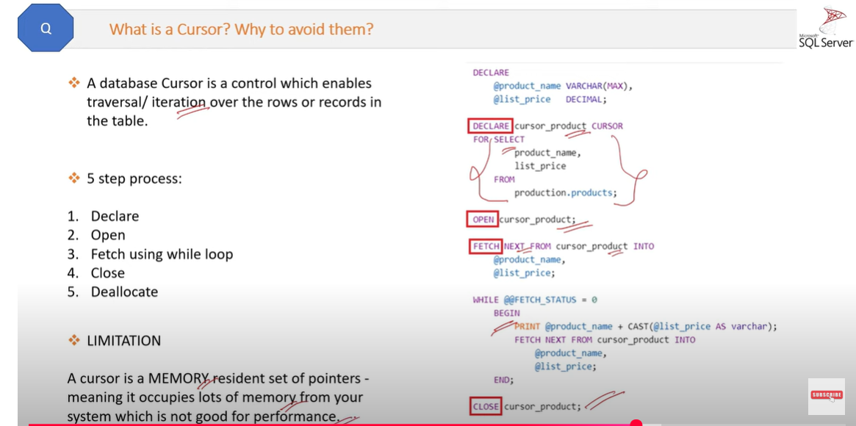

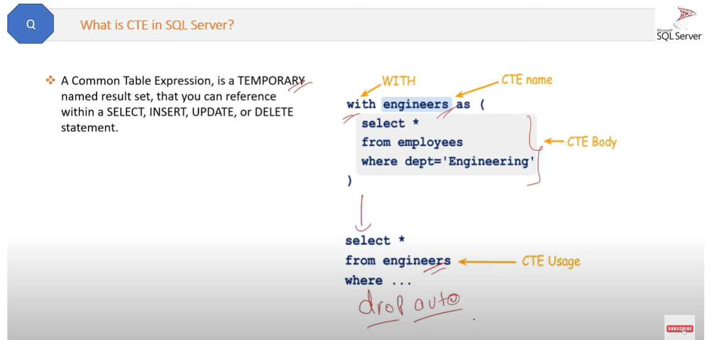

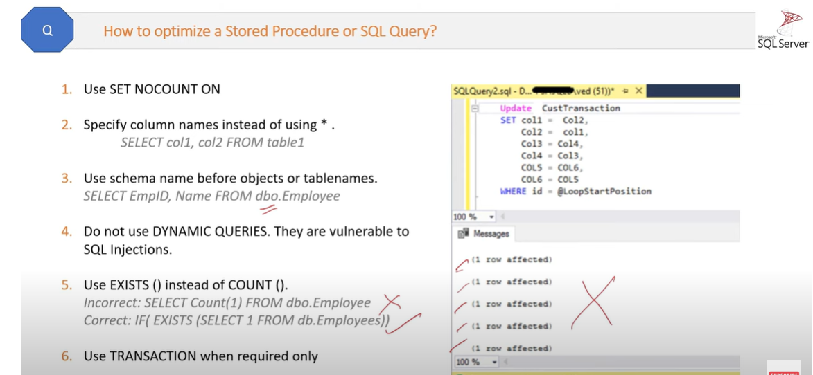

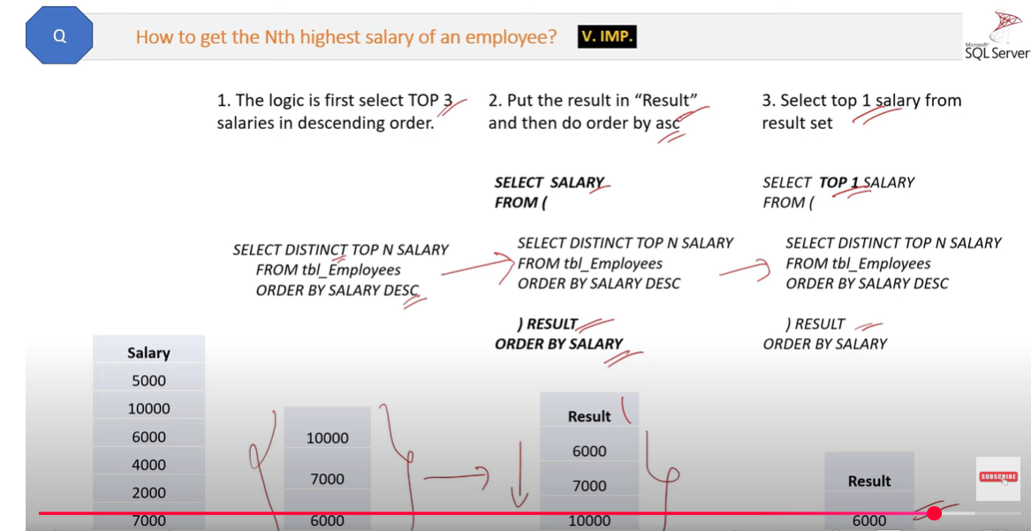

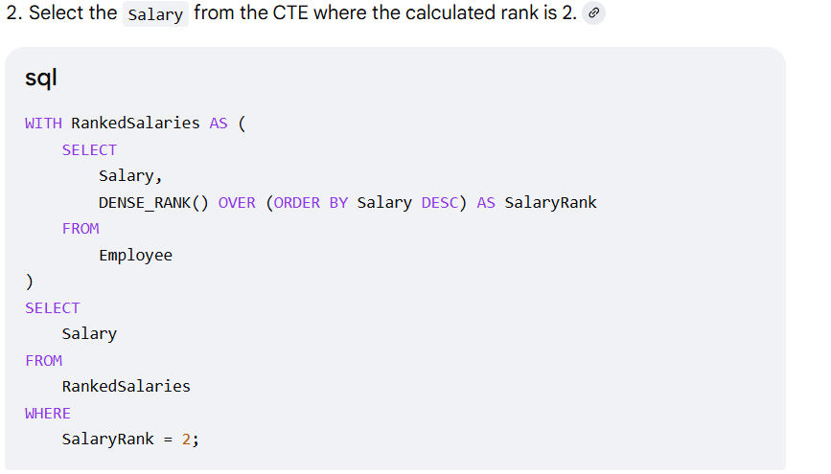

**Difference between CTE and View**

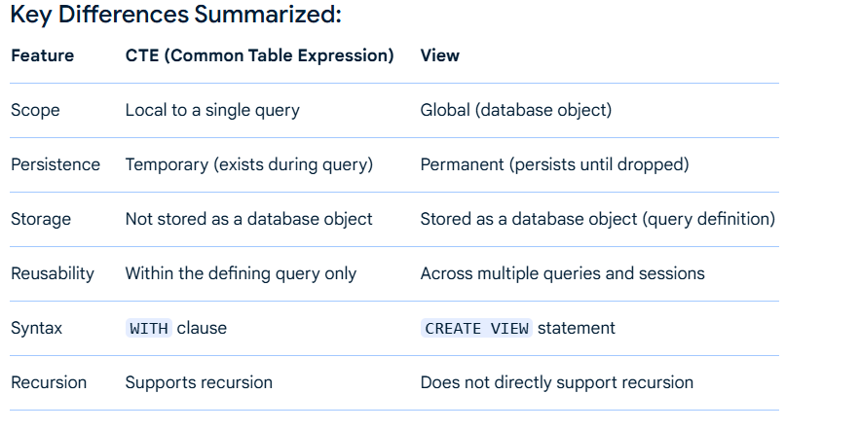

**Difference between CTE and temp table**

1. CTE table is accessible within define query only, whereas temp table is accessible across multiple queries globally and locally.
2. CTE is not directly indexable, temp table can be indexed.
3. CTE is not physically stored where temp table is stored physically in tempDB.
4. CTE is faster for small dataset whereas temp table is efficient for large dataset with indexing.

**Query Execution Plan in SQL server**

* An execution plan in SQL is a graphical or textual representation of the steps the database engine takes to execute a query.
* It helps in query performance and identify bottlenecks or inefficiencies.
* Understanding execution plans is crucial for query optimization and performance tuning.

Execution plans can be generated in two forms:

* **Estimated Execution Plan**: Generated before query execution, showing the predicted steps.
* **Actual Execution Plan**: Generated after query execution, showing the actual steps taken.

1. How do you diagnose and resolve **slow-running SQL queries**?

Microsoft SQL Server Profiler is a graphical user interface to SQL Trace for monitoring an instance of the Database Engine or Analysis Services. For example, you can monitor a production environment to see which Stored Procedures are affecting performance by executing too slowly.

**What is Tuning Advisor?**

The tuning advisor helps to get the performance report that is generated by SQL Profiler

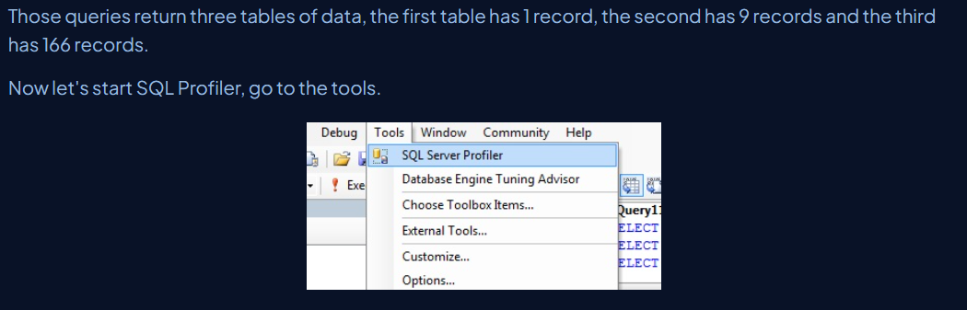

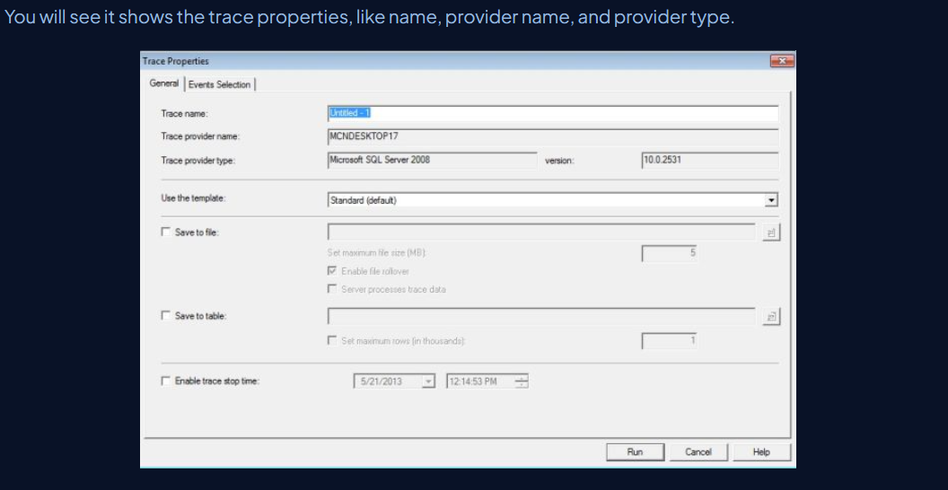

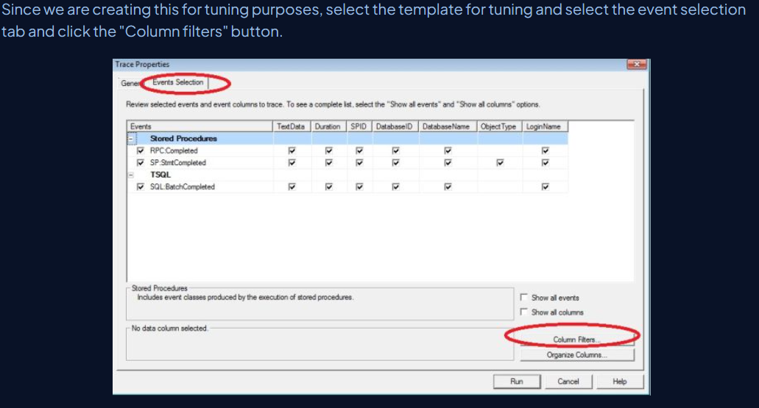

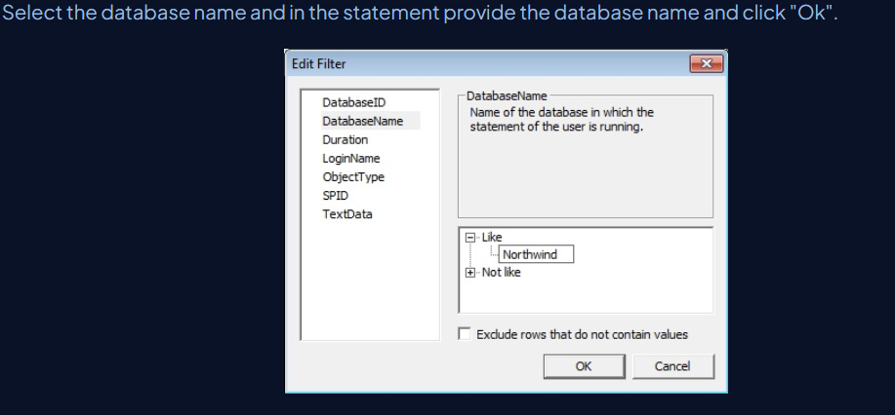

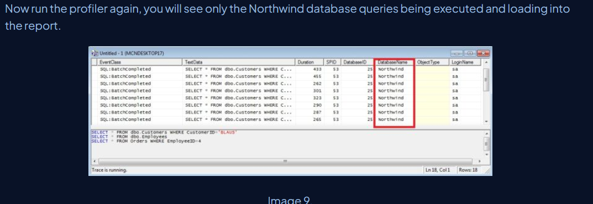

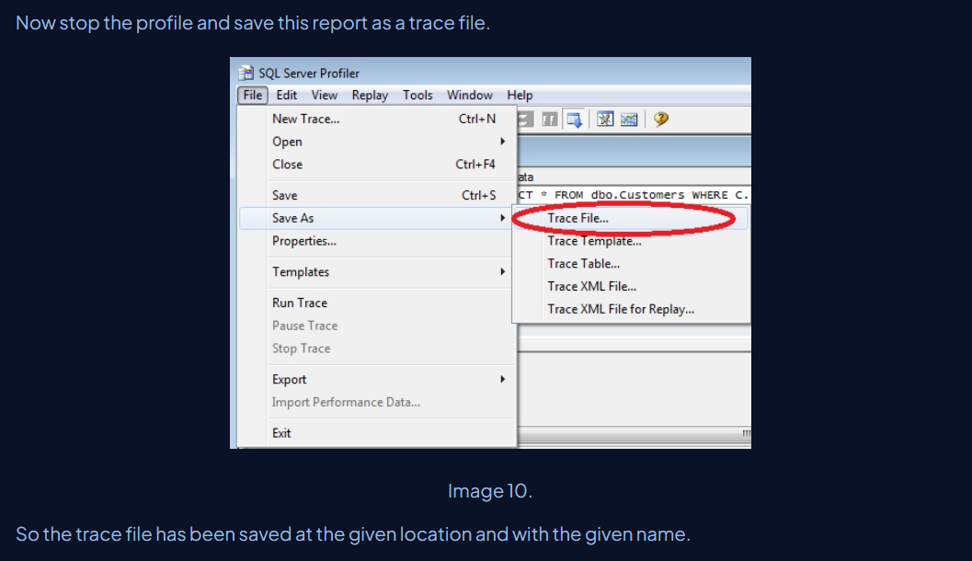

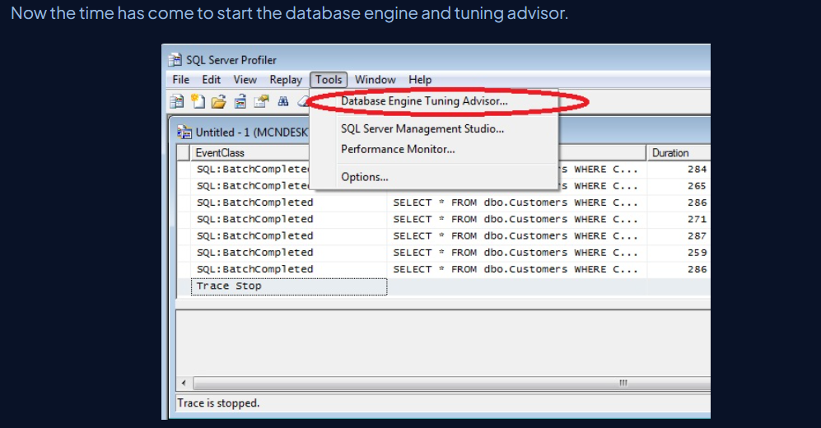

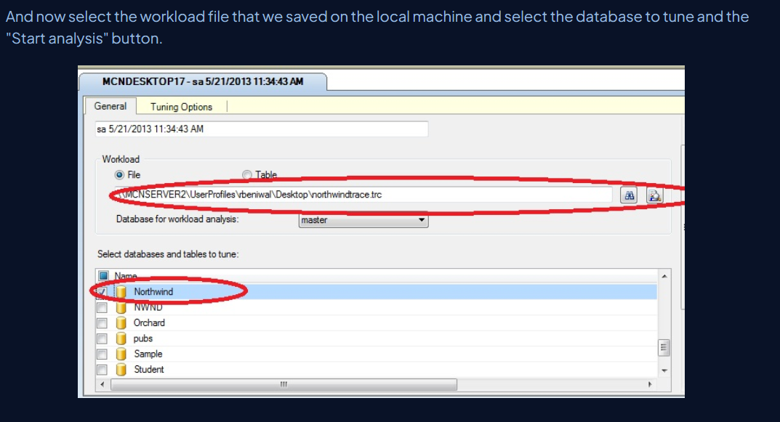

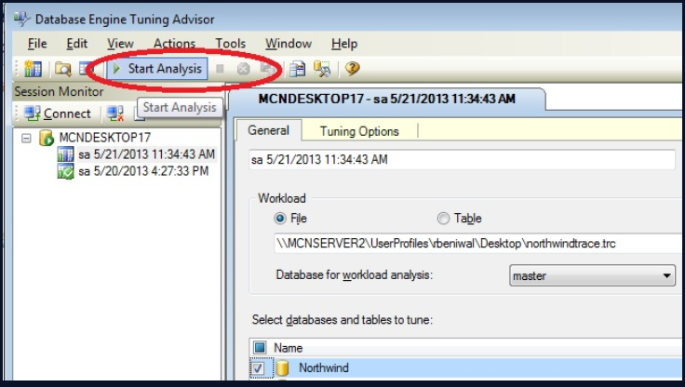

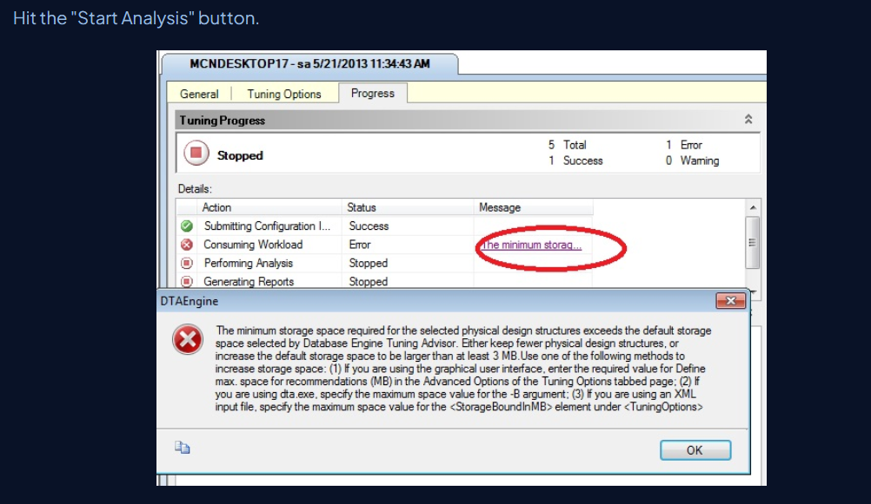

If you get this error then do the following to remove this error.

* Go to the Tuning Options tab
* Click the Advanced Options button
* Check the defined max space for recommendations
* Enter 5 in the text box
* Click "Ok"

Table A

-------

Col1

-------

Null

Null

1

1

1

Null

Table B

-------

Col1

-------

Null

1

1

Null

Give me resultset rowcount after joining above 2 table using below joins

* inner join =2 ?
* left join =5 ?
* rightjoin = ?
* full join = ?
* cross join = ?

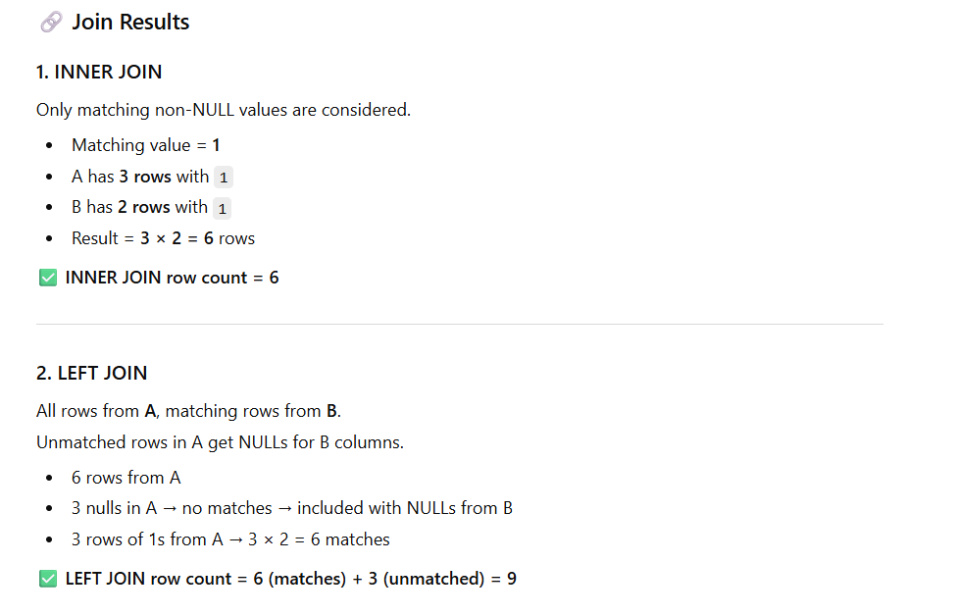

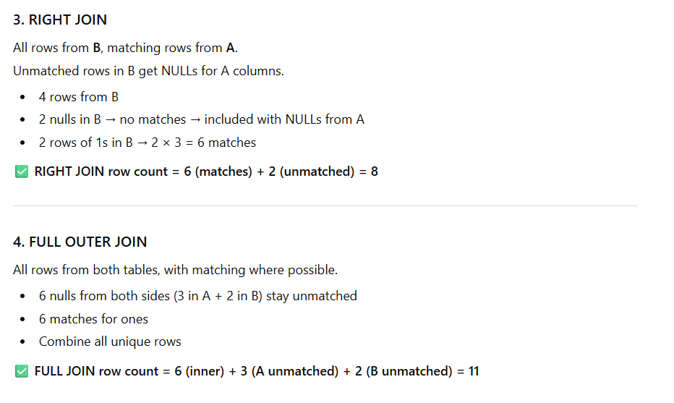

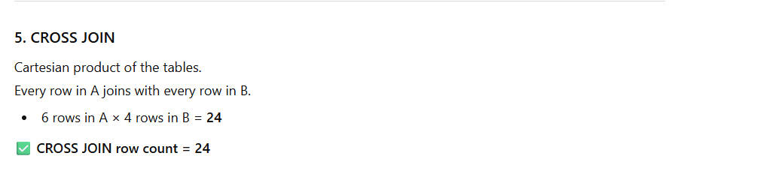

1. Explain the concept of **transaction isolation levels** and their effect on performance and concurrency.

**Isolation** is one of the properties of SQL Transaction. Isolating/separating transactions from each other to maintain Data Integrity in Database is called Isolation.

While developing large enterprise/public networking kind of applications where a huge number of users access same Database, same Table and at the same Time, Data concurrency situation may occur.

**Read Uncommitted**In this level, the transaction can read uncommitted data resulting in the Dirty Read problem. With this isolation level, we allow a transaction to read the data which is being updated by other transaction and not yet committed. Suppose User A is trying to read a row which is being updated by User B. Here, we are allowing User A to read the un-updated/uncommitted data i.e old data.

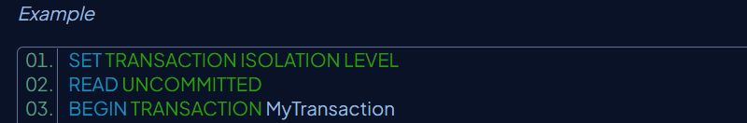

**Read Committed**  
This prevents Dirty Read. When this level is set, the transaction cannot read the data that is being modified by the current transaction. This will force user to wait for the current transaction to finish up its job. Suppose User A is trying to read a row which is being updated by User B. Here, we are asking User A to wait for the User B to finish its update task, and giving the updated/correct data to User A. But the problem with this level is - it can't resolve Phantom Read or Inconsistency Analysis i.e it asks User A to wait for Read but not for update or insert.

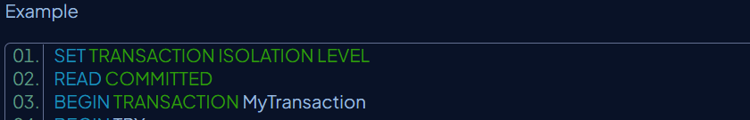

**Repeatable Read**  
This is same as Read Committed, but it has one additional benefit. User A will wait for the transaction being executed by User B to execute it's Update query as well, like Read Query. But Insert query doesn't wait, this also creates Phantom Read problem.

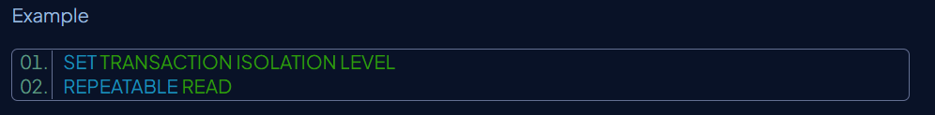

**Snapshot**  
This level takes a snapshot of current data. Every transaction works on its own copy of data. When User A tries to update or insert or read anything, we ask him to re-verify the table row once again from the starting time of its execution, so that he can work on fresh data.

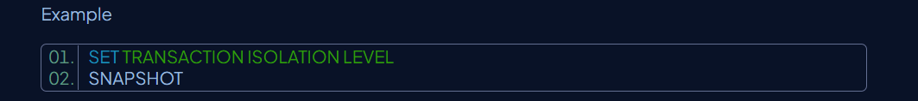

**Serializable**  
This is the maximum level of Isolation level provided by SQL Server transaction. We can prevent Phantom Read problem by implementing this level of isolation. It asks User A to wait for the current transaction for any kind of operation he wants to perform.

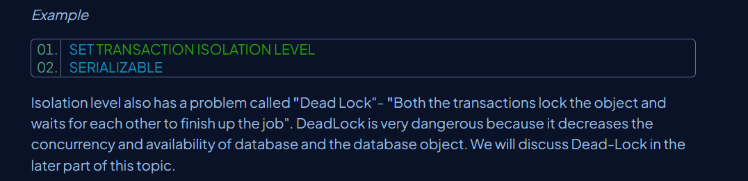

**What is normalization in Sql server?**

This is the process of organizing data to reduce redundancy and improve data integrity and consistency in our database.

* **First Normal Form (1NF):**
  + Each row must be unique.
* **Second Normal Form (2NF):**
  + The table must be in 1NF.
  + All non-key attributes must be fully functionally dependent on the entire primary key. This means no partial dependencies exist where a non-key attribute depends only on a part of a composite primary key.
* **Third Normal Form (3NF):**
  + The table must be in 2NF.
  + Eliminate transitive functional dependencies. This means no non-key attribute should be dependent on another non-key attribute.
* **Boyce-Codd Normal Form (BCNF):**
  + A stricter version of 3NF.
  + For every non-trivial functional dependency X -> Y, X must be a superkey. This addresses certain anomalies that 3NF might miss in cases with multiple candidate keys.
* **Fourth Normal Form (4NF):**
  + The table must be in BCNF.
  + Eliminate multi-valued dependencies.
* **Fifth Normal Form (5NF) or Projection-Join Normal Form (PJNF):**
  + The table must be in 4NF.
  + Eliminate join dependencies that are not implied by candidate keys.

**Query:**

SELECT c.CustomerName, totalOrders

FROM Customers c

JOIN (

SELECT CustomerID, SUM(TotalAmount) AS totalOrders

FROM Orders

WHERE YEAR(OrderDate) = 2025

GROUP BY CustomerID

HAVING COUNT(OrderID) > 5

) o ON c.CustomerID = o.CustomerID;

**Optimization**:

**SELECT c.CustomerName, o.totalOrders**

**FROM Customers c**

**JOIN (**

**SELECT**

**CustomerID,**

**SUM(TotalAmount) AS totalOrders**

**FROM Orders**

**WHERE OrderDate >= '2025-01-01'**

**AND OrderDate < '2026-01-01'**

**GROUP BY CustomerID**

**HAVING COUNT(OrderID) > 5**

**) o ON c.CustomerID = o.CustomerID;**

1. How do you implement **pagination** efficiently in SQL and in your API endpoints?

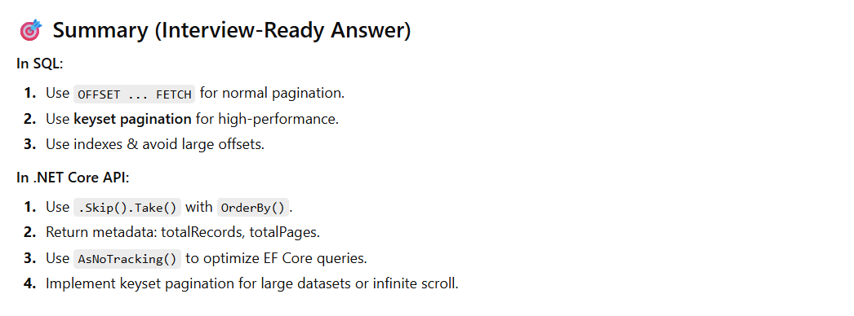

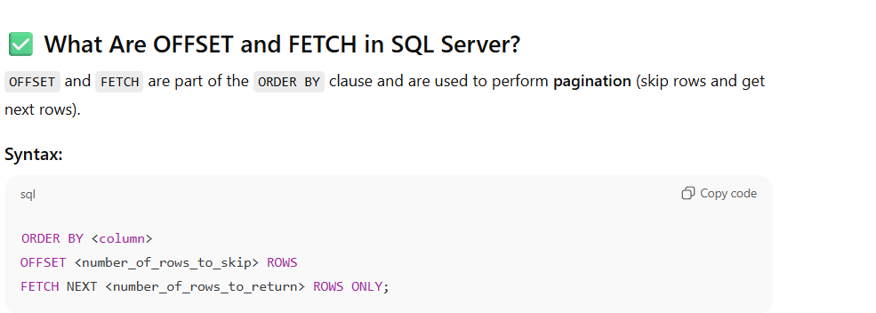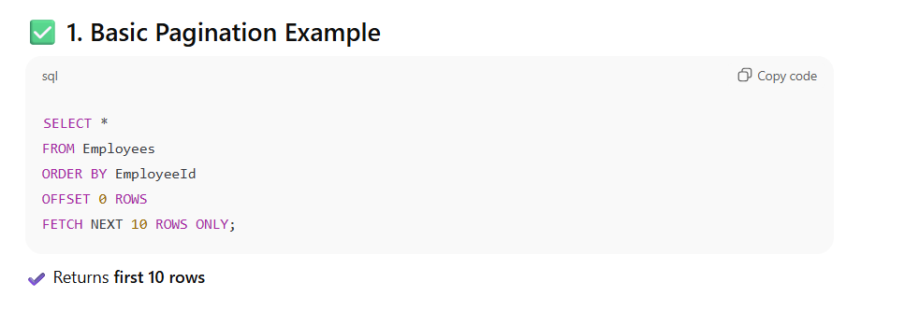

1. How would you design a **data access layer** in .NET that minimizes coupling and supports testability?